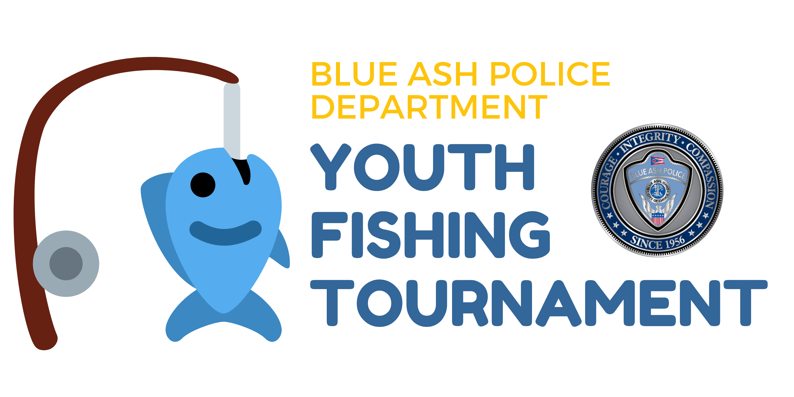
Blue Ash Police Department
Youth Fishing Tournament

Tournament Date: Sunday, May 5, 2024
Location: Fishing pond at Summit Park, 4335 Glendale Milford Road, Blue Ash, OH 45242
Fishing Times:
09:00 – 10:00 a.m. (Ages 5-8) check-in 8:30 a.m.
10:30 – 11:30 a.m. (Ages 9-12) check-in 10:00 a.m.
12:00 – 1:00 p.m. (ages 13-16) check-in 11:30 a.m.

See the official rules below. To participate, please fill out the waiver, and entry form at www.blueash.com/fishingtourney by April 19, 2024.
_____________________________________________________________________________________
Fishing Tournament Rules and Regulations
Decisions of the Tournament Director are final and not subject to appeal. Interpretation of these rules will be left exclusively to the Tournament Director in his sole and absolute discretion. Violation of a tournament rule may result in weight loss and/or disqualification from the tournament.
- PARTICIPATION AND ELIGIBILITY: Participation is open to any child, ages 5-16. In the event the Tournament registrations exceed the maximum amount of participants, Blue Ash residents (children) will receive priority. All participants and/or their parent/guardian must fill out a waiver and registration form to participate. The registration deadline is April 19, 2023. Forms can be found here: www.blueash.com/fishingtourney

No fishing license is required. Summit Park Lake is a catch-and-release only body of water.

Participation is limited to 50 children in each age group. Any exception will be determined solely by the Tournament Director.

Only fish caught by the registered participant will count as an official catch.

- CHECK-IN TIMES:
- 8:30 a.m. - Ages 5-8
- 10:00 a.m. - Ages 9-12
- 11:30 a.m. - Ages 13-16

- SAFETY: Water safety practices must be followed at all times. The tournament times may be shortened or canceled due to unsafe weather or any other condition that would endanger the safety of the competitors and the tournament staff. All fishing will be done from the bank. Participants are permitted to wear life-saving devices of their own, if desired, while fishing.

- PERMITTED FISHING METHODS: Only one fishing pole per angler may be used at any one time. One additional rod may be brought and ready to use; however, each cast and retrieve must be completed before another cast is attempted or another rod is used. All fish must be caught alive, in a conventional sporting manner.

- SPORTSMANSHIP AND CONDUCT: All contestants and their guests are required to follow the highest level of sportsmanship, courtesy, safety, and conservation. Any violation of these rules may result in disqualification from the tournament and forfeiture of any prizes.

- NO ALCOHOL and/or ILLEGAL DRUG USE will be permitted at the event by any contestant or guest.

- ASSISTANCE: The expectation is that each contestant will cast and retrieve their own fishing lure/hook including reeling in a fish. Minimal assistance by a guardian or helper is permitted. Those contestants needing additional accommodations and/or assistance should notify the Tournament Director prior to the start of the competition.

- SCORING: Pounds and ounces will determine the largest fish. The length of the fish will resolve ties. If a tie still exists, the winner will be decided by the flip of a coin.

- LIVE FISH: Every effort must be made to keep fish alive. Fish are required to be weighed and released as soon as possible after being caught. All contestants must use the fish bag provided by the tournament. Please ensure there is water in the bag to keep the fish alive while transporting them to be weighed. NO DECEASED FISH WILL BE WEIGHED IN.

- The beginning and ending of the fishing times will be indicated with the sound of a siren. No fishing will be permitted prior to the start of the session and no fishing will be permitted once the siren sounds to end the session. No pre-fishing will be permitted on the day of the event.

